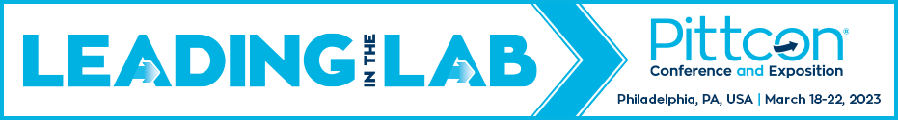
Conference Summary
Complete this worksheet for each Pittcon Conference element you attended. The purpose of this sheet is to document educational experiences, action items, and estimated return on investment for each session.

Type of session attended:

Symposium
Oral Session
Poster Session
Award Session
Workshop
Coulter Lecture
Short Course
Networking Session
Other: _________________________

Session/Course Title:

Session/Course Presenter(s)/Instructor(s):

Session/Course Abstract:

Key Concepts, Techniques, and Tips:

Action Items:

Estimated Return on Investment:

Professional Contacts
Include contact information for all presenters and attendees you plan to contact.
Name:

Contact Details:

Discussion and Potential Usefulness:

