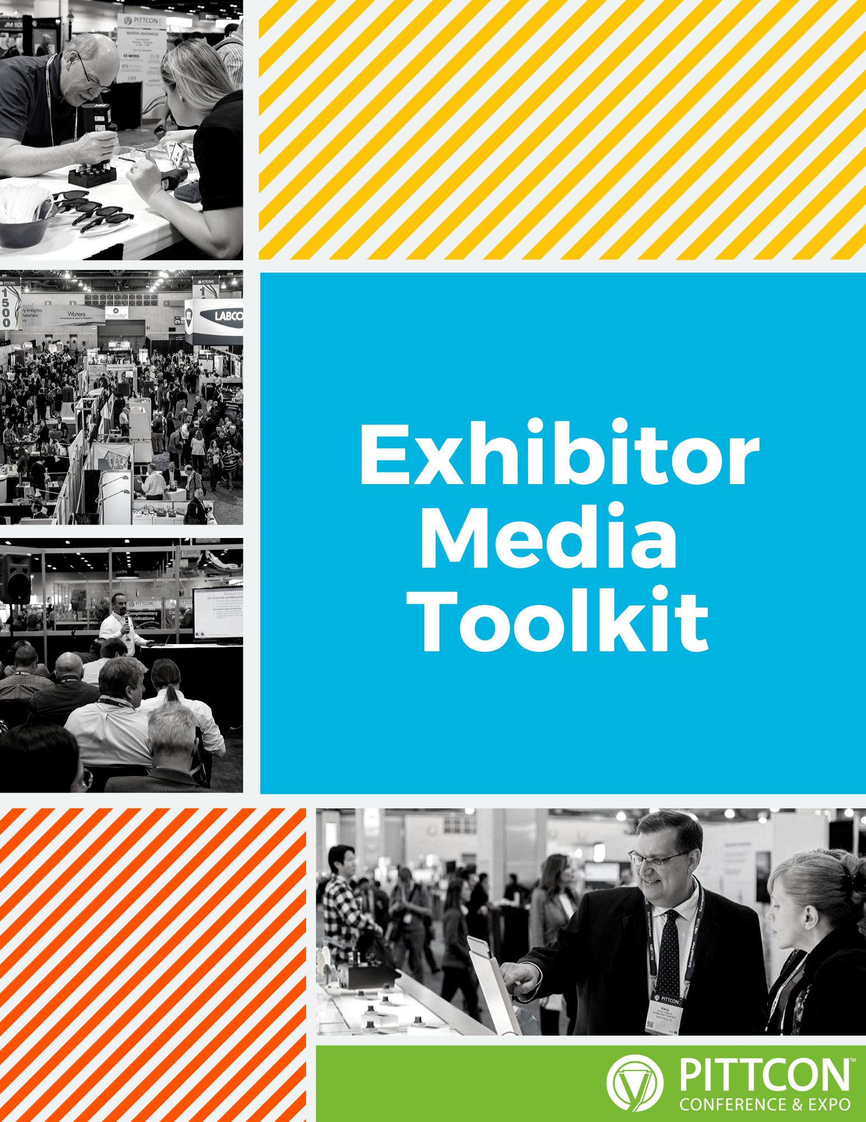

Checklist................................................3
Press Release Template...............................................4
Email......................................................5
Social Media Posts......................................................6
Become a Sponsor.................................................7
Sponsor Email......................................................8
Sponsor Social Media Posts..........................................9
Additional Information..........................................10

Utilize the following to build buzz and engage with your customers:

☐ Schedule at least 5 social media posts in advance; include your booth number and the hashtags #Pittcon and #pittcon2023 and maybe even #Pittconparty.

☐ Send an email to let your customers and partners know you’ll be at Pittcon.

☐ Engage with attendees during the conference using #Pittcon, #pittcon2023, and #pittconparty.

☐ Write a blog post about your experience when you return.

☐ Submit press releases and/or white papers for posting on pittcon.org.

☐ Download the registered media list at pittcon.org.
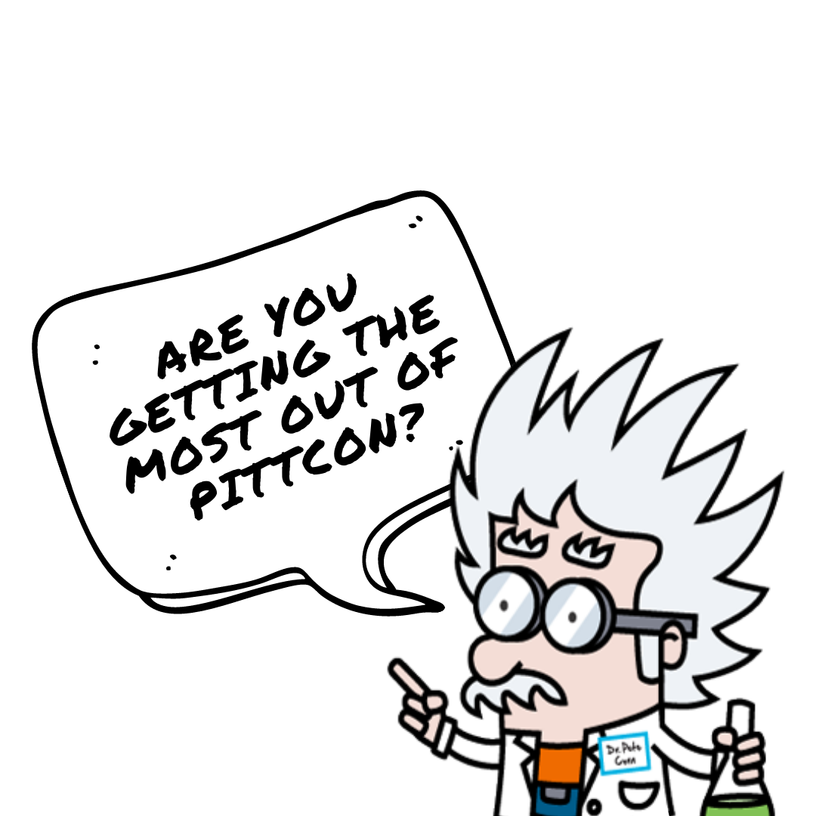
☐ Put a customized Pittcon banner ad on your company’s website.

If you are a Pittcon exhibitor AND sponsor, then make sure to promote that as well. We’ll provide content later in this document to help with promoting your partnership with Pittcon as an exhibitor-sponsor.
{Image of Company Logo}

FOR IMMEDIATE RELEASE

Media Contact: {First & Last Name} {Phone Number (XXX) XXX-XXXX} {Email Address}

{Company Name} to Exhibit at Pittcon 2023 in Philadelphia, PA, USA

{City, State} – {Release Date} – From March 20 to 22, 2023, {Company Name} will head to Philadelphia for Pittcon, the world’s leading annual conference and exposition on laboratory science. {Returning to Pittcon for the XX year} OR {Exhibiting at Pittcon for the first time}, {Company Name} will showcase {describe what is being showcased, leading with what’s new} at {Booth Number}.

Pittcon’s Exposition showcases the latest products, services, and innovations in all areas of analytical chemistry, applied spectroscopy, life science, and a broad number of scientific disciplines to a global audience.

During the 2023 Exposition, {Company Name} will showcase/debut {insert product and details about offerings, activities, promotions, etc.}.

In 2023, the three-day Expo will run from 9am-5pm from March 20, 21, and 22. On average, over 500 exhibitors showcase their products and services including nearly 100 international companies and over 100 first-time exhibitors.

{Quote from company spokesperson}

For more information, visit our {Company Website}, stop by {Booth Number} during Pittcon 2023, or tweet along with us using the #Pittcon hashtag.

About {Company Name}
{Company Boilerplate}

About Pittcon
Pittcon is a dynamic, transnational conference and exposition on laboratory science, a venue for presenting the latest advances in research and scientific instrumentation, and a platform for continuing education and science-enhancing opportunity. Our aim is to advance scientific endeavor through collaboration, bringing together a world of knowledge to impact, enrich, and inspire the future of science. Pittcon is a catalyst for the exchange of information, a showcase of the latest advances in laboratory science, and a venue for international connectivity. Over 90% of Pittcon’s annual net profit funds scientific grants, education, laboratory improvements, and outreach. pittcon.org

Subject Line:
Will We See You at Pittcon This March?

Body Content:
{Company Name} is excited to announce that we’ll be heading to Pittcon 2023 in Philadelphia, PA! From March {Dates}, look for our team who will be {debuting/showcasing innovation} at Booth {Booth Number}.

{Include unique details about your company’s promotions, swag, sessions you’re excited to attend, and/ or high level executives in attendance.}

Like you, we can’t wait to take advantage of photo ops at the LOVE sculpture, Reading Marketing, and taste-testing the famous Philly Cheesesteak and Philly Soft Pretzel. But we’re most excited for the chance to see all of you in person. Pittcon is one of the few annual events where we can step out from behind our screens and show you that your business is personal to us.

Leading up to the Conference and Expo, we encourage you to join the conversation with {Twitter handle} using the #Pittcon hashtag. We can’t wait to see you at Booth {Booth Number} this March!

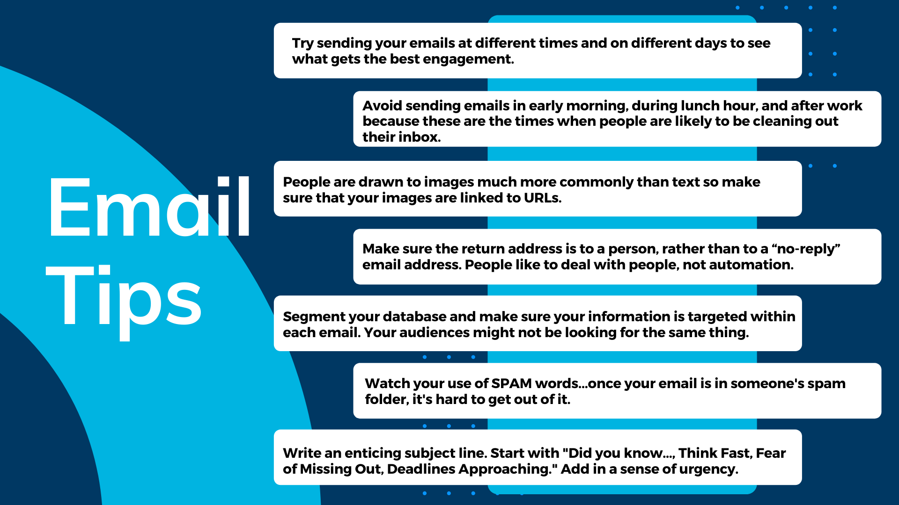

**View SPAM Words**
Use the following drafted social media posts for Twitter, Instagram, Facebook, and LinkedIn:

- Ready to talk {Topic}? Our experts will be at #Pittcon 2022 in Philadelphia this March! Look for us at Booth {Booth Number}.

- To see the latest and greatest lab innovations from {Company Name}, come check us out at #Pittcon in Philadelphia March 20-22.

- Come see {Company Name} at @Pittcon Booth {Booth Number}! We’ll be in Philadelphia March 20-22.

- Save the date: We’ll be at #Pittcon in Philadelphia March 20-22! Visit us at Booth {Booth Number} to experience our innovations up close.

- Want to see what we have in store for #Pittcon 2023? Come see us at Booth {Booth Number} and find out for yourself!

Being a Pittcon exhibitor and sponsor shows Pittcon attendees that you care about the scientific community as much as you care about the quality and distinctiveness of the scientific instrumentation you are exhibiting at Pittcon 2023.

Moreover, being a Pittcon sponsor is a promotional opportunity that your company will want to tell all prospective customers in preparation for Pittcon 2023. Think of it more as a partnership with Pittcon, and the following will help you tell others about it:

Subject Line:
Did you know?

Body Content:
{Company Name} is honored to announce its in-part sponsorship of Pittcon 2023 in Philadelphia, March {dates}. Not only will we be exhibiting our latest innovations at Booth {booth number}, but this year {Company Name} will also be giving back to the scientific community through our partnership with Pittcon.

Did you know that Pittcon is a non-profit organization that gives over 90% of its annual proceeds to further scientific endeavors? Pittcon supports science equipment grants, research grants, scholarships, and internships for students, awards to teachers and professors, and grants to public science centers, libraries, and museums. This is why {Company Name} is proud to be a sponsor of Pittcon 2023.

{Include unique details about your company’s particular sponsorship, your involvement in the scientific community, and your anticipated participation at Pittcon 2023.}

Like you, we want the future of science to be a bright one – we achieve that goal only by working together. This is why {Company Name} has partnered with Pittcon. We want to help today’s students become tomorrow’s scientists, laboratory managers, teachers, professors, and innovators.

Leading up to the Conference and Expo, we encourage you to join the conversation with {Twitter handle} using #Pittcon. We can’t wait to see you at Booth {Booth}.
Show your customers that by sponsoring Pittcon, you’re sponsoring resources to support new scientists that will change the world:

- We want the future of science to be a bright one. That’s why we’re partnering with #Pittcon as a sponsor this year.

- We’ll be at #Pittcon this year as an exhibitor and as a sponsor. We’re proud to partner with Pittcon to support today’s students, tomorrow’s scientists.

- {Company Name} supports innovation in laboratory science and beyond, which is why we’re honored to be an in-part sponsor at this year’s #Pittcon!

- {Company Name} supports our scientific community and this year we’re partnering with #Pittcon to help further our shared mission of paying it forward.

- #Pittcon gives back over 90% of its annual proceeds to furthering the scientific community. That’s why {Company Name} is proud to be a Pittcon 2023 sponsor.

- Visit the {Sponsorship Purchased} at #Pittcon this March, proudly sponsored in part by {Company Name}!

For more information on exhibitor ROI, marketing opportunities, and materials to help you promote your presence at Pittcon, visit https://pittcon.org/exhibitor/marketing-resources/

For additional information or questions, contact:

Rocco Pacella
Marketing & Communications Manager
Email: pacella@pittcon.org
Phone: 412-825-3220 x202

Sarah Wagner
Marketing Coordinator
Email: wagner@pittcon.org
Phone: 412-825-3220 x203

