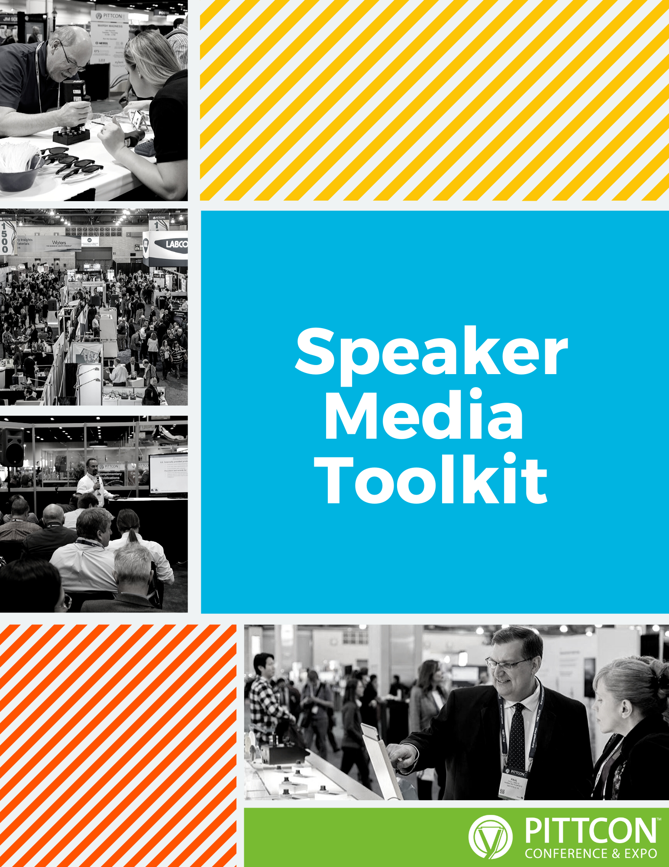

Checklist................................................3
Social Media Posts......................................................4
Email......................................................5
Additional Information...........................................6

Show attendees why YOUR session is unmissable, then keep the momentum going:

☐Schedule social media posts in advance; include your session’s title, day and time
and don’t forget #pittcon.

☐Send an email to your network to let them know you’ll be at Pittcon.

☐Engage with attendees and other presenters during the conference using
#pittcon.

☐Send follow-up emails to all your new contacts when you return.

☐Write a blog post summarizing the high points of your session.
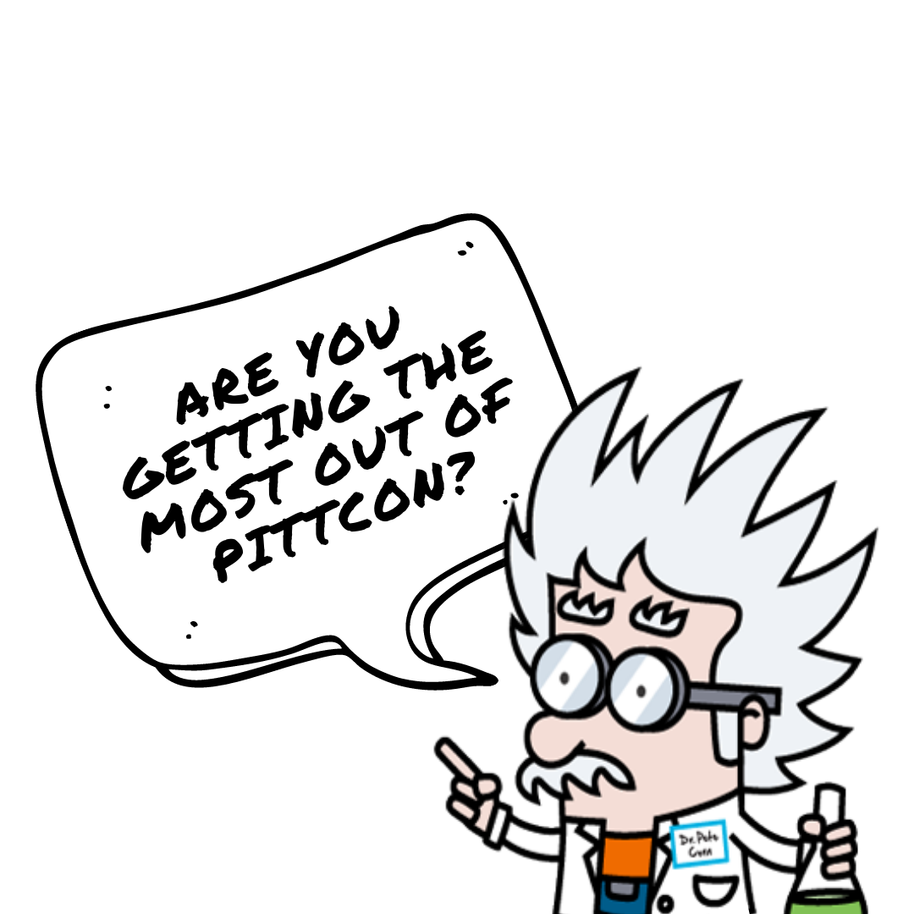
- Confirmed! I’ll be a speaker at #pittcon in Atlanta this March, delivering a presentation on {Topic}. Make sure to mark your calendars.

- On March {Date}, I’ll be talking to @Pittcon attendees about {Topic}. Have any questions for me? #pittcon

- Join me on my journey to Atlanta, where I will be presenting about {Topic} at #Pittcon! I’ll be in town from March {Dates}.

- There’s a lot to love about #pittcon 2022. This year we’ll be heading to Atlanta. Plus, I’ll be speaking about the latest in {Topic}.

- Planning your #pittcon? On {Date} I will be teaching a {Duration} Short Course on {Topic}. Register now at pittcon.org/register/

- This year, @Pittcon’s Short Courses will include a session on {Topic}. Bonus: I’ll be teaching it! Register now at pittcon.org/register #pittcon

- Have you registered for @Pittcon Short Courses yet? Keep an eye out for my session on {Topic}. pittcon.org/register #pittcon

Subject Line:
A Lecture [or Presentation or Talk] on {General Topic}

Body Content:
I am both honored and excited to announce that I will be giving a lecture [or Presentation or Talk] at Pittcon 2022 in Atlanta! My lecture, entitled {Title of Lecture in Italic Font} will be held on March {Date} at {Time} at Georgia World Congress Center convention center, room {Room Number}.

{Include details about your lecture/presentation/talk and what you hope attendees to learn from it.}

Like you, I can’t wait to see what Atlanta has to offer, but I’m most excited for the opportunity to share my knowledge with you, directly and in person at Pittcon. This is one of the few annual events where scientists, academics, and experts like us can collaborate with each other, advance our fields of study, and enrich one another’s professional expertise.

Leading up to the Conference and Expo, I encourage you to join the conversation with me on {Social Media Platform and Handle} using #pittcon. I can’t wait to see you at {Title of Lecture in Italic Font} this March at Pittcon 2022.
For additional information or questions about marketing your presentation/session, contact:

Rocco Pacella
Marketing & Communications Manager
Email: pacella@pittcon.org
Phone: 412-825-3220 x202

Sarah Wagner
Marketing Coordinator
Email: wagner@pittcon.org
Phone: 412-825-3220 x203

